Insertion Sort Problem.
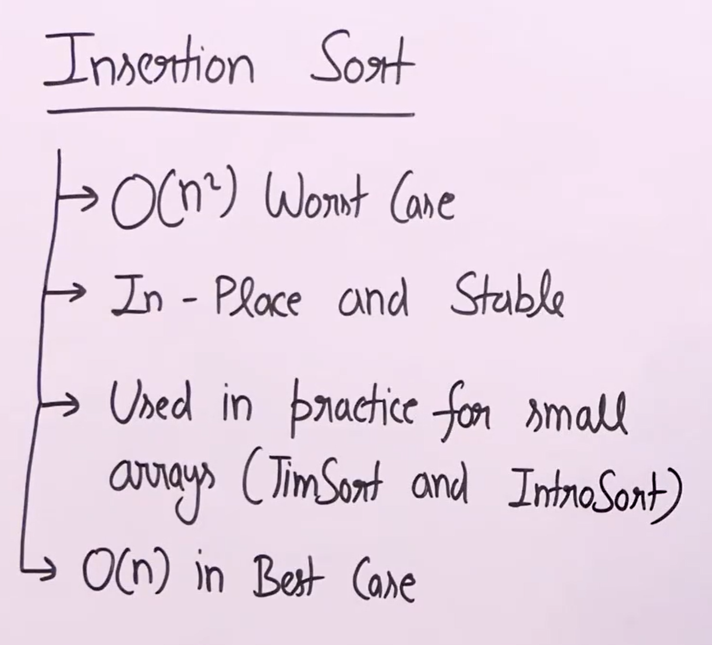
An in-place algorithm is one that transforms the input data structure without requiring significant additional memory space. More formally:
- It uses only O(1) extra space (constant extra space)
- It modifies the input array/data structure directly
- It does not create a separate copy of the input data



